**Quibble, The Queen’s Basic Event Ticket Service**

**Assignment 2: Front End Rapid Prototype**

**Christopher Thomas, 10066835**

**Nicholas Smith, 10098522**

**Thursday October 22nd, 2015**

**Design Documentation**

**Language:**

We are implementing our Quibble program in Java. We will be using only one main class, with the starting (main) method being used for the login, which subsequently calls a “kiosk” method to manage Quibble’s behaviour as the user enters transactions. Each transaction (create, sell, return, etc.) will also have its own method.

**Class**

MainClass.java: This main class handles the entire function of the Quibble system, including all the requests from the user, tracking current events and transaction data, etc.

**Methods**

main(String args[]): The main starting method which begins a user session by having the user type in ‘login’. It is essentially an infinite while loop to facilitate and endless cycle of different user sessions, as on a real-life kiosk system, the user will always be able to login.

logout(): This method is only called when the user types ‘logout’ when presented with the list of possible transactions. We have a method for this, as there will be transaction data being written to a file, and separating this processing is much cleaner.

create(): Create is a method that is only available if the user is an admin. Once the admin enters all necessary event information, the ArrayLists storing current event data are updated with the new event.

add(): Add is a method that is only available if the user is an admin. The admin is able to increment the number of tickets available for an existing event.

delete(): Delete is a method that is only available if the user is an admin. This method deletes all information related to a particular event from the current events records.

sell(): Sell is a method that is available to any user. Sell will examine ticket information for current events and allow the user to purchase tickets for an event of their choice.

return(): Return is a method that is available to any user. Return allows the user to return previously purchased tickets to a given event.

**System Overview**

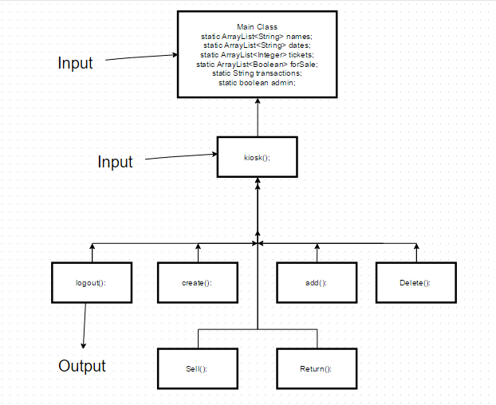

Each method will be responsible for its function as described above, resulting in a concise structure of methods all working together. Input comes in through MainClass, such as ‘login’ in the main method. Other user input to drive Quibble’s functionality and transactions will be typed in through the kiosk() method and the methods it calls – create(), delete(), add(), sell(), return(), and logout(). Also, the currentEvents.txt file is read into the program in the kiosk() method.

Once the user has supplied a desired transaction type in kiosk(), it will call the appropriate method to do the work. Once they are finished the transaction, they are returned to the kiosk() method where they are able to either perform another transaction, or logout of the current session. Upon logout, the dailyTransactions.txt file is generated and exported.